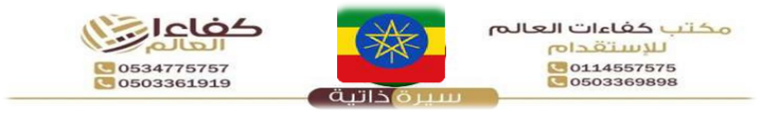

{%facePhoto} |  |  | Reference Number |  |  | {refNumber}
 |  |  | Full Name |  |  | {fullName} |  | الاسم
 |  |  | Religion |  |  | {religion} |  | الديانة
 |  |  | Position Desired |  |  | {position} |  | الوظيفة
 |  |  | Salary |  |  | {salary} |  | الراتب
 |  |  | Age |  |  | {age} |  | العمر
 |  |  | Sex |  |  | {gender} |  | الجنس
Personal Information |  |  |  | معلومات شخصيه |  | Passport Information |  | معلومات الجواز
Nationality |  | {nationality} |  | الجنسية |  | Number | {passportNumber}
Date of Birth |  | {dob} |  | تاريخ الميلاد |  | Issue Date | {issueDate} | الإصدار
Address |  | {address} |  | العنوان |  | Expiry Date | {expiryDate} | الانتهاء
Marital Status |  | {maritalStatus} |  | الحالة الاجتماعية |  | Issue place | {issuePlace} | الاصدار
No. of Children |  | {numberOfChildren} |  | عدد الأطفال |  | Next of Kin name | {emergencyName} | خص
Height/Weight |  | {height} / {weight} |  | الوزن والطول |  | Next of Kin number | {emergencyPhone} | رتب
Education Qualifications |  | {educationLevel} |  | المستوى التعليمي |  | {%fullBodyPhoto}
Tel. Number |  | {phone} |  | رقم التواصل
Overseas Experience |  |  | خبرات سابقه
Country |  | Period | Position
{expCountry} |  | {expPeriod} | {expPosition}
Skills |  |  | المهارات
Cooking | {skillCook} | الطبخ | Baby Sitting | {skillBaby} | التعامل
Washing | {skillWash} | الغسيل | Sewing | {skillSew} | الخياطة
Cleaning | {skillClean} | التنظيف | Driving | {skillDrive} | سائق
Languages |  |  | اللغات
 | English  الانجليزية |  | Arabic  العربية
Good | {english} |  | {arabic}
Fluent | NO |  | NO
REMARKS: SHE IS HARDWORKING, NEAT, ORGANISED, SMART, DISCIPLINED, CARING, HAS A GOOD ATTITUDE, SPEAKS GOOD ENGLISH AND LOVES TAKING CARE OF CHILDREN.

Scan for Video / QR Code
{%qrCode}

Passport Image
{%passport image}

